**Rio 2016: Olympic athletes told to ‘keep your mouth closed’ when in contaminated water**

July 28, 20162:44pm

Environmentalists protested against water pollution in Rio de Janeiro?s iconic Guanabara Bay, which will be the venue of Olympic Games? sailing events this summer. Activists staged a mock funeral on Botafogo Beach on Saturday, February 27, loading a coffin with rubbish picked up from the sea. They called for a ban on trash and sewage being dumped in the area. Biologist Mario Moscatelli said the government had not responded to a report he filed in May on the conditions of Guanabara Bay, reported Brazilian TV station Globo. Credit: Antonio Carlos

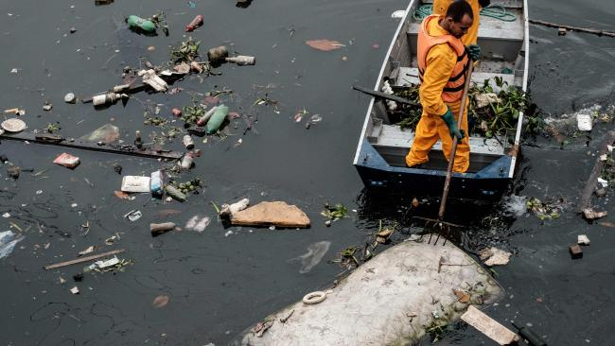

Environment Institute of Rio de Janeiro State staffers collect a bed mattress as the tide moves away from the eco-barrier set up to catch floating debris before they enter Guanabara Bay, next to Rio de Janeiro, Brazil. Picture: Yasuyoshi Chiba

Scientists say the waters are filled with a host of pathogens and viruses with recent tests showing it is more contaminated than first thought, [*The New York Times*](http://www.nytimes.com/2016/07/27/world/americas/brazil-rio-water-olympics.html?_r=0)reported.

One doctor told *The Times* that athletes will “literally be swimming in human crap”.

Paediatrician Daniel Becker also warned they were at risk of getting sick from microorganisms and toxins in the water.

Health experts have advised competitors to keep their mouths shut.

Afrodite Zegers, a member of the Dutch sailing team, has been practising in Guanabara Bay, renowned for its high levels of pollution.

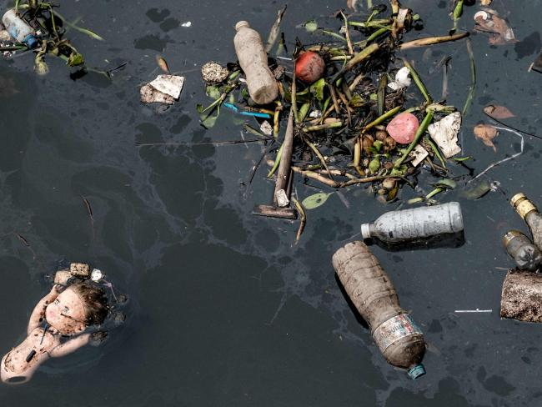

Floating debris, carried by the tide, is caught by the eco-barrier before entering Guanabara Bay. Picture: Yasuyoshi ChibaSource:AFP

Organisers have been scrambling to clean the waterways in the lead up to the games. Picture: Yasuyoshi ChibaSource:AFP

“We just have to keep our mouths closed when the water sprays up,” she told [*The Times*](http://www.nytimes.com/2016/07/27/world/americas/brazil-rio-water-olympics.html?_r=0).

One local revealed his disappointment that authorities weren’t able to clean up the water properly in time for the games, revealing “it smells like (expletive) because it’s full of (expletive)”.

Luiz Goldfeld told *[USAToday](http://www.usatoday.com/story/sports/olympics/rio-2016/2016/07/26/rio-de-janeiro-dirty-water-sewage-guanabara-bay/87525622/" \t "_blank)* he expected something would be done about the problem when the Olympics were announced in 2009.

However according to him, little has changed in seven years with tonnes of raw sewage pumped into the bay every day.

He said the stench was often overpowering and that he had seen human waste and dead animals in the water.

However some have pointed out the events being held in the bay are actually a long way from where the worst pollution levels are.

London-based Brazilian singer-songwriter Isabel Monteiro tweeted the negativity surrounding pollution was misleading.